
Prepared for [Entity] by UConn TAB
Student Contributor: [Name]
Spring 2025

[TOWN/CITY OF, STATE]
Brownfield Inventory
[Town/Region]-Wide

Table of Contents
EXECUTIVE SUMMARY iii
LIST OF FIGURES iv
LIST OF TABLES iv
ACRONYM/ABBREVIATION LIST v
1. BACKGROUND 1
1.1 COMMUNITY DESCRIPTION 1
1.2 SUMMARY OF EXISTING DATA 1
1.2.1 SUMMARY OF GRANTS RECEIVED BY ENTITY 2
2. PROJECT SCOPE AND OBJECTIVE 2
2.1 REGULATORY GUIDANCE 2
3. METHODOLOGY 2
3.1 DEVELOPMENT OF the INVENTORY 2
3.2 LIMITATIONS 3
3.3 BROWNFIELD PRIORITIZATION CRITERIA 4
4. RESULTS/FINDINGS 4
4.1 INVENTORIED SITES Summary 4
4.2 PRIORITY SITES 5
4.3 Completed sites and success stories 5
5. CONCLUSIONS AND RECOMMENDATIONS 5
REFERENCES & LINKS 6
APPENDICES 6

EXECUTIVE SUMMARY
Provide an Executive Summary of the Report here.

LIST OF FIGURES
Figure 1. Figures are images such as photographs, maps, screen captures, etc. Assign each Figure in this Report a Figure Number and list them here by title in sequential order as they appear.

LIST OF TABLES
Table 1. Assign each Data Table in this Report a Table Number and list them here by title in sequential order as they appear.

ACRONYM/ABBREVIATION LIST
Amend this Table with acronyms utilized in the Report, delete any not relevant.
Abbreviation | Meaning
ACRES | Assessment, Cleanup and Redevelopment Exchange System
ATSDR | Agency for Toxic Substances and Disease Registry
BI | Brownfield Inventory
BGFST | Brownfields Grant Fact Sheet Tool
CDC | Center for Disease Control
CEJST | Climate and Economic Justice Screening Tool
CEQ | Council on Economic Quality
CIMC | Cleanups in My Community
EJ | Environmental Justice
EUR | Environmental Use Restriction
FEMA | Federal Emergency Management Agency
FIRM | Flood Insurance Rate Map
FRS | Facility Registry Service
FY | Fiscal Year
GIS | Geographic Information System
ICMA | International City/County Management Association
ID | Identification
MA DEP | Massachusetts Department of Environmental Protection
MA OEJE | Massachusetts Office of Environmental Justice & Equity
LUST | Leaking Underground Storage Tank
NDDB | Natural Diversity Database
NFIP | National Flood Insurance Program
SVI | Social Vulnerability Index
TOD | Transit-Oriented Development
UConn TAB | University of Connecticut EPA Region 1 Technical Assistance to Brownfields Program
US EPA | United States Environmental Protection Agency

1. BACKGROUND

1.1 COMMUNITY DESCRIPTION
Text, Figures and Tables – Be sure to use State-relevant terminology where applicable
Provide an image of the entity’s location
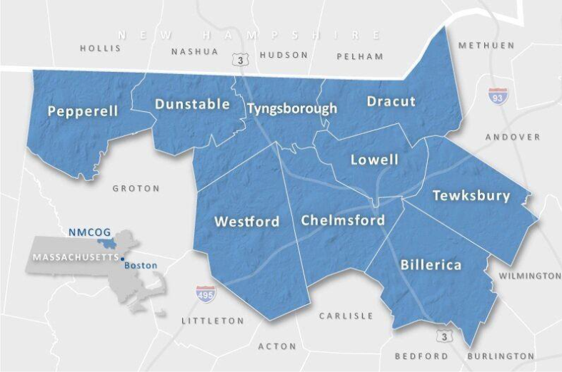
Describe the entities’ industrial past and what would have led to the presence of brownfields in the community(s) today. What were they known for? When did industry shut down?
Briefly describe the city/town (population and population trends, demographics [e.g., children or seniors], socioeconomic conditions [e.g., low-income, employment, language proficiency], housing trends [e.g. housing costs, owner vs. renter occupied, housing costs as % of household income]). Population and demographics can be both written and included in a table/figure. Include food access classification (and define it) and mention of nearby food stores. If applicable, when defining whether the Target Site is located within an EJ community, describe the state-specific definition of EJ/EJ community and reference the specific legislature. (2-3 paragraphs maximum)
If you are working with a regional entity, create a table to break down the populations of each, population densities, and other useful information.
Use the table below to outline information to include but DO NOT include the table!
EJ Designation (state-specified, include a reference to the state legislature defining EJ/EJ communities)
Other sensitive populations given by ACS data
Population Size and Population Trends
Neighborhood makeup (rural, suburban, urban)
Food Access (is this a food desert? USDA FARA classification)
Nearby public facilities & services (including municipal services, parks, and open space)

Businesses Nearby (largest employers, is site in commercial zone/district, overview of nearby businesses and general commercial setting)

Community Stakeholders (federal/state level if applicable, local government and boards, community-based groups and charities)

1.2 SUMMARY OF EXISTING DATA
Text and Tables where applicable – Be sure to use State-relevant terminology where applicable
The following are examples of sources that can be utilized, replaced with source names, acronyms and data for this Inventory. Please use the examples below as an example of how to compile your list of existing data. Yours will be updated based on the state you are working within as well as entity type.
- Massachusetts Department of Environmental Protection (MA DEP) Brownfields List 2018
Database identifies 8 potential brownfield sites of which 4 are included in the Inventory.
- US EPA Brownfields Grant Fact Sheet Tool (BGFST) - Excluding Job Training Grants
Database identifies 4 Assessment or Cleanup Grants for 9 brownfield sites located in [Town/City], 8 of which are included in the Inventory (3 have since been successfully redeveloped and noted as Complete in Column H “Status”.
Though not identified in this database, an additional EPA Assessment Grant though the US EPA’s FY22 Targeted Brownfield Assessment (TBA) program was awarded for property located at 41-43 Orange Street, which is included in the Inventory.
- US EPA Cleanups in My Community (CIMC)
Utilizing the [Town/City] as the Geographic Area of Interest and the “All Cleanups” basic filter to show all potential sites, the database identifies 11 sites, of which 2 are included in the Inventory.
- US EPA Region 1 Assessment, Cleanup and Redevelopment Exchange System (ACRES)
Database identifies 2 brownfield sites, both of which are included in the Inventory.
- US EPA Region 1 ACRES Update Received September 2024 (Excel Spreadsheet)
Database identifies 2 brownfield sites for which funding has been awarded for Assessment or Cleanup activities, both of which are included in the Inventory.
- US EPA Facility Registry Service (FRS): Regional Facilities & Sites Subject to Environmental Regulation
Database identifies 17 facilities and/or sites in Chelsea that are subject to environmental regulation, only 1 of which is included in the Inventory.
- US EPA EnviroFacts
Utilizing the Brownfield – Cleanups Search “What are the potential sites identified by the Brownfields Program in my area of interest?” and utilizing [Town/City] zip code XXXXX to define the area of interest, this database identifies 8 sites of which 6 are included in the Inventory.
- Site Visit/Reconnaissance
The site visit conducted by UConn TAB staff with [Name and Title of Municipal Contact] on [Date] identified 6 potential brownfield sites that were not included in any of the data sources listed above, 3 of which are included in the Inventory.
- [Town/City] Assessor’s Tax Delinquency List
Database did not identify any previously unknown brownfield sites, nor were any of the already inventoried brownfield sites on the tax delinquency list.

1.2.1 SUMMARY OF GRANTS RECEIVED BY ENTITY
This section should include all EPA/State grants the entity has received.
[Town/City] Assessment FY98 $200K 2 Sites on Everett Ave. Urban Renewal Dist.
[Town/City] Cleanup FY07 $200K Lawrence Metal Forming Co. - Beech St.
[Town/City] C-W Assessment FY23 $500K Multiple Sites
MA DEP C-W Assessment FY24 $2M Boston Hides & Furs - Marginal Ave.

2. PROJECT SCOPE AND OBJECTIVE
Include the scope and objectives of this project. Such as who asked for it, what information will it include. What is it limited by? How can it be used? Where is the scope of the work being conducted?

2.1 REGULATORY GUIDANCE
The main guideline that was used to identify the Brownfields in the Town of Dalton was the EPA’s definition of a Brownfield which is stated as follows: “A brownfield is a property, the expansion, redevelopment, or reuse of which may be complicated by the presence or potential presence of a hazardous substance, pollutant, or contaminant.” Beyond this, guidance is more practical in terms of whether an individual Brownfield inventory candidate has the apparent hallmarks of a Brownfield, which include being un- or under-utilized, and having a history of usage likely to indicate presence or potential presence of contamination.

3. METHODOLOGY

3.1 DEVELOPMENT OF the INVENTORY
Text, Figures and Tables – Be sure to use State-relevant terminology where applicable
To identify known brownfield sites for this Inventory, multiple data sources were utilized to compile the initial list of properties as previously explained in Section 1.2 above. Generally, these sources are databases of properties for which one or more specific environmental condition is known to exist, either through prior study and documentation or having been registered with or reported to a state or federal regulatory agency. The range of environmental condition(s) causing a property to be included in one or more of these databases may be the result of: (1) historic employment of a specific land use; (2) employment of processes that utilize or produce hazardous materials; (3) required registration and/or reporting for storage, use, and disposition of certain hazardous materials; (4) required registration and/or permitting for hazardous or potentially hazardous discharge (release) to land, air or water; or (5) a single isolated event, such as a spill or accidental release.
The data sources identified in Section 1.2 rendered 1,381 entries in the City of Lowell, with some entries appearing multiple times (i.e., not 1,381 unique entries). These resources provided a broad overview of properties throughout the city with documented environmental conditions or property tax delinquency. After compiling this initial list, duplicate sites were consolidated (multiple data sources are noted in Column A “Source”) and some grouped sites were separated into individual properties.
The qualitative methodology used to further refine the list and identify brownfield sites was based on several factors, including but not limited to: {This section may or may not exist}
- Appearance in >1 of the primary data resources described in Section 1.2, above.
- Sites that appear currently abandoned, vacant or underutilized, with presence or potential presence of contamination were considered brownfields per EPA’s definition.
- Municipal landfills, active public utility facilities and Superfund Sites that are on the National Priority List (NPL) are not considered brownfields.
- Sites for which TAB staff has determined had undergone (somewhat) recent redevelopment are categorized as “Successfully Redeveloped Brownfield Sites”.
- Abandoned/underutilized buildings that were built prior to the 1950s with no indication of renovation were considered brownfields due to potential presence of hazardous building materials given the age of the buildings.
- Sites with previous uses as residences (built after 1970s) were not considered brownfields.
- Full in-use sites with active businesses were not considered brownfields.
- Sites with no suspected contamination (no record in release database, no indication of previous industrial uses on property card, no suspected HBMs based on age of building) were not considered brownfields.
Property-specific information derived from these data sources and included in the Inventory are summarized in Table 2, below:
Table 1. Site-Specific Data Included in Brownfield Inventory
Source | Current Zoning | Opportunity Zone
Descriptive Comments | Current Owner | EJ Community
Site Name (if applicable) | Tax Payment Status | Federal or State Program
Address | # of Buildings | TOD Zone
Zip Code | SF of Buildings | Public Utilities
GIS Parcel Number | Year Built | Links
Assessor’s Unique ID | FEMA Flood zone | Contaminants (if known)
Site Type | Wetlands | Additional Comments
Site Size (acres) | Vulnerability Index

3.2 LIMITATIONS
This Inventory may not be an all-inclusive list of brownfield sites in the [Town/City], as it primarily contains sites for which some information regarding environmental condition(s) currently exists and is discoverable. Other sites not listed in the Inventory may be present in [Town/City] that: (a) have unknown environmental conditions that have not yet been identified or reported; (b) were developed or redeveloped without knowledge of environmental conditions; or (c) were developed or redeveloped with knowledge of environmental conditions but for which State or Federal grant funding was not utilized (with or without Environmental Use Restrictions (EURs) in place). Additionally, this Inventory represents a “snapshot” in time, being current only up to the date upon which UConn TAB’s property research was concluded.
Include any information here that you may not have been able to find and is listed as unknown on the report.

3.3 BROWNFIELD PRIORITIZATION CRITERIA
Text, Figures and Tables – Be sure to use State-relevant terminology where applicable
The prioritized Sites are identified further in Section 4.2, below.
This section should outline the criteria used to determine prioritization. It should explain how prioritization came to be as well as write out the scoring itself.

4. RESULTS/FINDINGS

4.1 INVENTORIED SITES Summary
Text, Figures and Tables – Be sure to use State-relevant terminology where applicable.

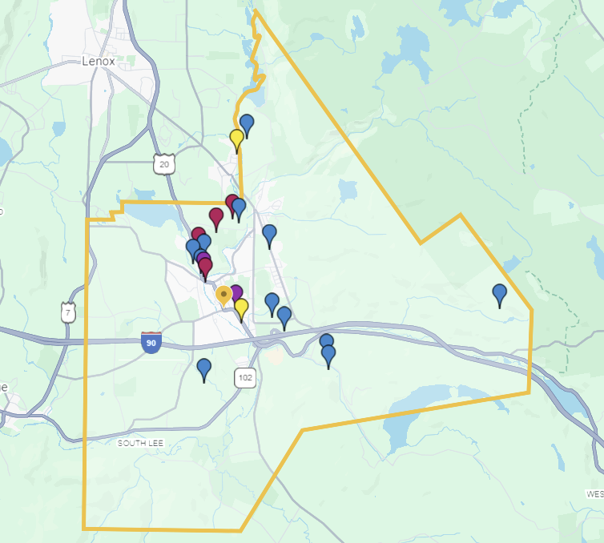
Figure X. Inventoried Brownfield Site Locations in Chelsea (Base Map: Google)
Replace with Map with Priority Sites for this Inventory.
(You will be working with ArcGIS to create a map)

Include information regarding the map create such as a legend regarding the colors and how many sites were identified. If you are working with a regional entity, break down the number of sites by municipality using a table or figure.

Below the image, include a table with Address and GIS parcel number for all identified sites. Can make multiple columns. If subcategories are created, point those out in tables below.

4.2 PRIORITY SITES
Text, Figures and Tables – Be sure to use State-relevant terminology where applicable. Can use any type of image for tables below but make them consistent.
Table X. Priority Brownfield Sites per [Source]
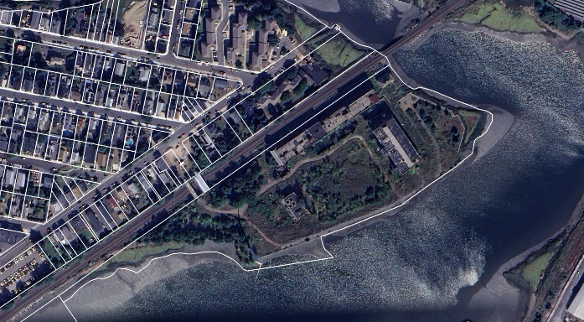 | SITE NAME: Forbes Lithograph  ADDRESS: 1 Forbes Street  DESCRIPTION: Former Industrial Site  ZONING: Waterfront (W)  ACREAGE: 17.42

Replace image and site information with Priority Sites for this Inventory. Replicate as necessary.

4.3 Completed sites and success stories
This section should discuss the “completed” sites within the inventory. Discuss what the site used to be and what it is now. If there is information about capital stacks or information on how the redevelopment was accomplished, include that here. Images of the sites are encouraged.
Table X. Completed Brownfield Sites per [Source]
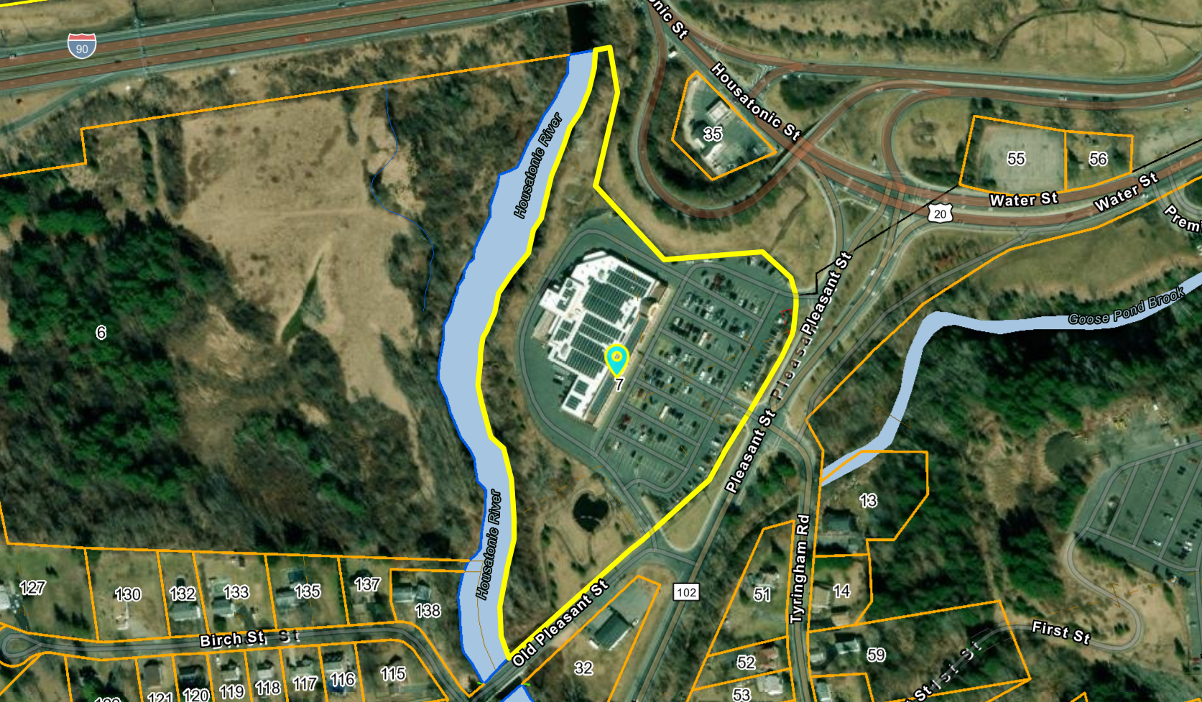 | SITE NAME: Diesel Dans  ADDRESS: 10 Pleasant Street (Route 102)  DESCRIPTION: Former truck stop and petroleum site  ZONING: Commercial Business Corridor (CBC)  ACREAGE: 9.63  CURRENT USE: Big Y Foods
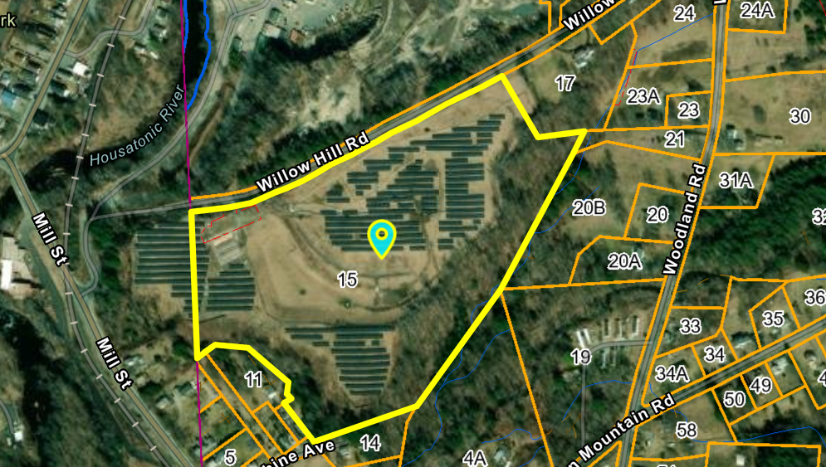 | SITE NAME: Schweitzer/Willow Hill Landfill  ADDRESS: 70 Willow Hill Road  DESCRIPTION: Former landfill – closed and capped in 1994  ZONING: Industrial (I)  ACREAGE: 25.706  CURRENT USE: Willow Hill Road Solar Farm

5. CONCLUSIONS AND RECOMMENDATIONS
This section should summarize what you found, what you did, and how the entity can use this information. It should also recommend next steps for both this information as well as brownfield efforts in that community.

REFERENCES & LINKS
CDC/ATSDR SVI
https://www.atsdr.cdc.gov/placeandhealth/svi/index.html
CEJST
https://screeningtool.geoplatform.gov/en/#12.66/42.39915/-71.03187
Chelsea, MA Vision Government Solutions
https://gis.vgsi.com/chelseama/
EJScreen
https://ejscreen.epa.gov/mapper/index.html?wherestr=CHelsea+MA
US EPA Brownfields Grant Fact Sheet Tool
https://java.epa.gov/acrespub/gfs/
US EPA Cleanups in My Community (CIMC)
https://cimc.epa.gov/ords/cimc/f?p=CIMC:LIST
US EPA EnviroFacts
https://www.epa.gov/enviro/topic-searches#toxics

US EPA Regional Facilities & Sites Subject to Environmental Regulation
https://www.epa.gov/frs/epa-regional-kml-download

Amend this list with additional sources of information (including hyperlinks) cited or utilized in the preparation of this Report, delete any not relevant.

APPENDICES
Appendix “A” – PDF copy of Brownfield Inventory Excel Workbook

